1. If we want to make alias and call every time that alias.

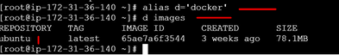

1. We pulled a Ubuntu image from docker hub if we will run the Ubuntu image in **dt** mode than in background default cmd will run always. If we will log in the **dt** mode runned container as **it** mode than another process will run but if we exist than **it** mode runned process will kill but actual cmd created container will run continuous.

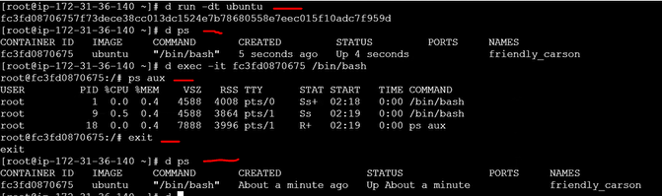

If same ununtu image we will run as it mode than it will login into container and run default cmd process and if we will exist than it will kill the process.

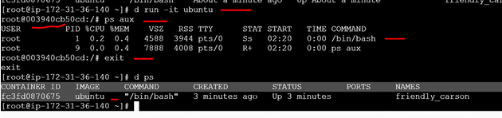

If we runned a container in **it** mode as argument /bin/bash than the process will override and login to container but if we want to run the process and we should not exist/kill only we will quite and that process will run. Than command is **ctrl p q**.

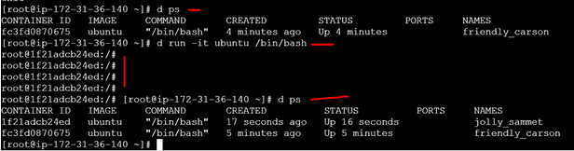

1. **Dt** uses for run the container purpose and **It** uses for debugging purpose.
2. Show all the process and only existed.

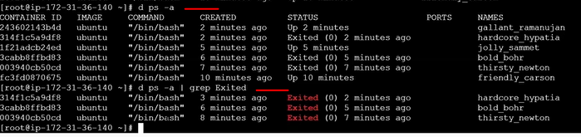

1. Some containers are running than I need to stop the server. If I stopped than how we will start again.

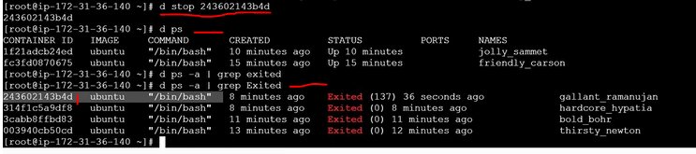

If we want to kill, start.

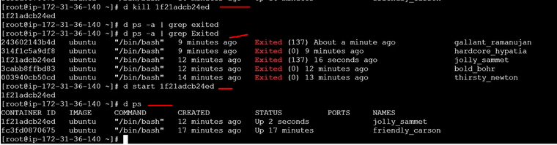

1. How to delete a stopped container.



1. How to delete a running container forcefully. Than run docker ps command and show how may containers are running.



1. If I want to remove all the stopped container.



If we check after that what are the existed or stoed than nothing.



1. If we want to delete all running and stoped, Existed containers.

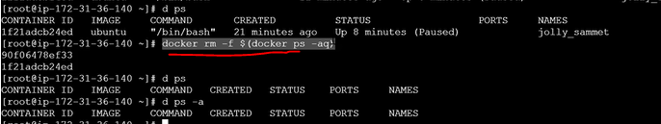

1. How we will delete a image.

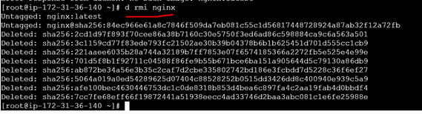

1. How we will delete all the images.

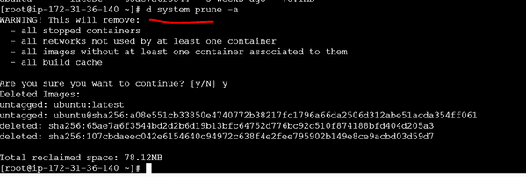

1. How we will run a container in some port.

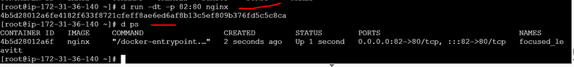

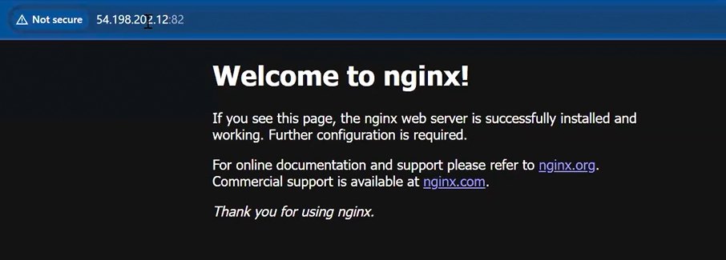

1. In a running container how we will port forward.
2. Now I will pull Jenkins image from docker hub and started running in port.

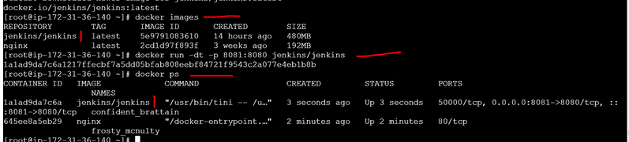

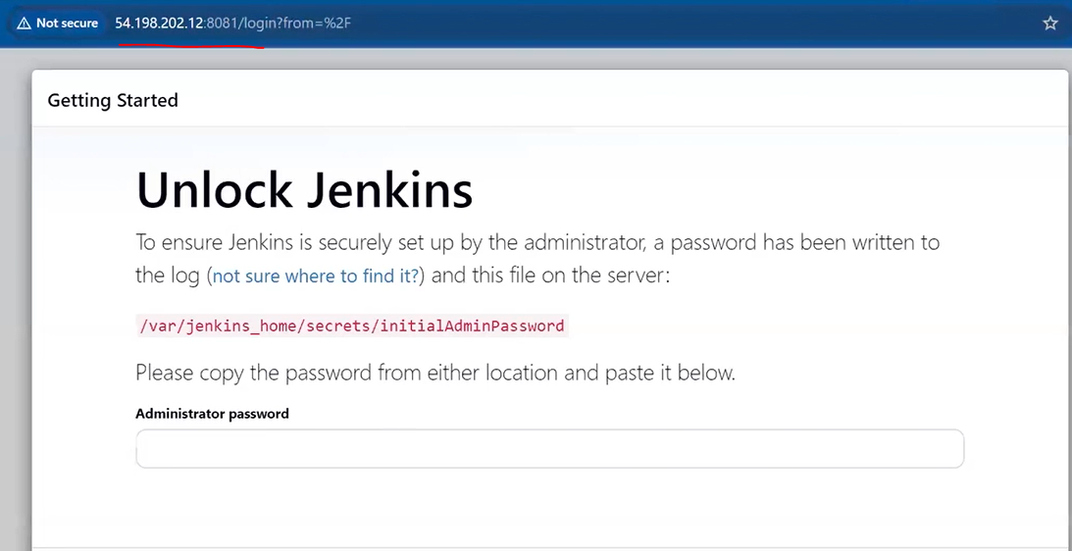

Than we will login into container and take password from container.

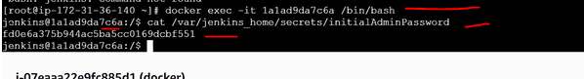

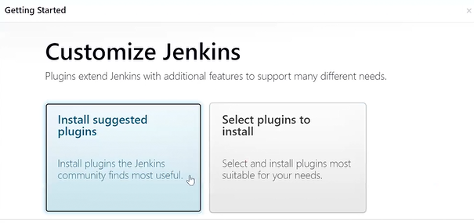

1. I want to run a python program in docker container.
2. Now I will pull amazon linux.

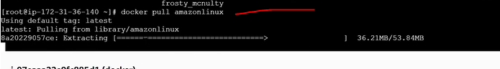

1. Now login into the container.

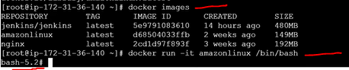

1. Now we are in amazon linux server. If we want to run python program than we will install python in docker linux server.But python is inbuilt present in docker hub python image.

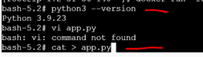

1. Now we will paste the code directly. Enter to next line than ctrl+c

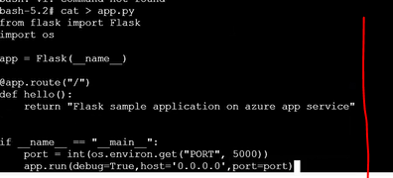

1. Default directories in docker amazon linux server.



1. We will create a python folder than we will move app.py file to inside python folder than check if its moved or not. Than came to that path and run python program than it will through error because **flask** dependency is not present. To intall **flask,**  pip command should be present but **pip** command also not present.

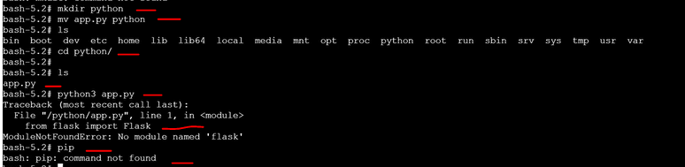

1. Once we installed pip and flask dependency than run app.py inside container.